$400 Hong Kong Dollar Ingredients

* Quick Cook Oat Meal 1kg
* Brought From Best Mart 360 ~ $18
* Total Price: $18

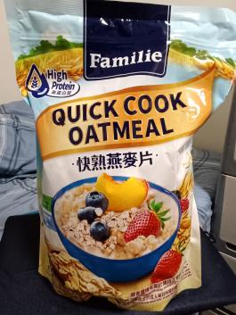

* Chicken Chops X 13
* Brought From Market ~ $11
* Total Price: $143

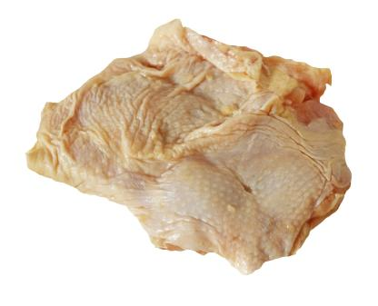

* Rice 5kg
* Brought From Best Mart 360 ~ $49 (Member Price)
* Total Price: $49

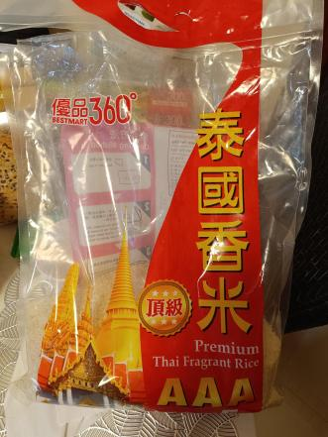

* Vegetables (any vegetables) 5kg
* Brought From Market ~ 1kg ~ $12
* Total Price: $60

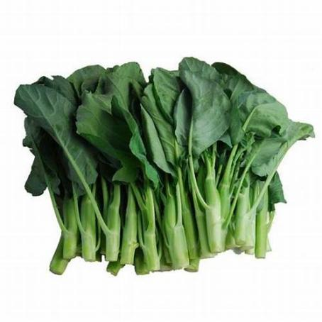

* Longevity Filled Evaporated 400GM X 3
* Brought From welcome Supermarket ~ $9
* Total Price: $27

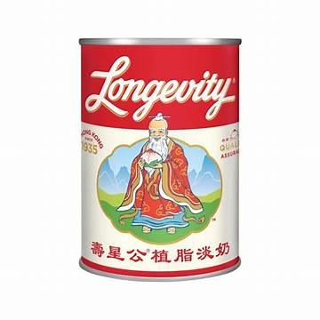

* Longevity Sweetened Milk 374GM X 3
* Brought From welcome Supermarket ~ $11
* Total Price: $33

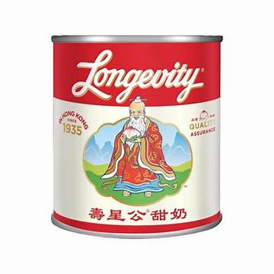

Devondale Milk X 7

* Brought From ParknShop Supermarket ~ $17.9 For 2 / $19.9 For 1
* Total Price: $73.6

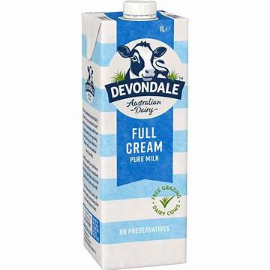

***Total Price: $403.6 (Last Updated: 16th May 2025)***

**Meals - 3 meals Plus Snacks**

**(Breakfast, Lunch, Dinner, Snacks)**

* Breakfast Oat Meal
  + Oat 8 tea spoon (equivalent to 40 gram)
  + Longevity Filled Evaporated (40 ml)
  + Longevity Sweetened Milk (30 ml)
  + Water (500ml)
* Morning Snacks

# Self made Yougurt ~ With Yougurt maker (小熊乳酪/酸奶机)

* Longevity Sweetened Milk (3.7 ml)
* Lunch
  + Meat Raw ~ 81 gram
  + Vegetable ~ 83.33 gram
  + Rice ~ 125 gram
    - Add water to the pot
    - Add meat (Marinated with salt) and vegetable when the water is fully boiled.
    - Wash the rice and steam the rice.
    - Served.
* Afternoon Snacks
* Self made Yougurt ~ With Yougurt maker (小熊乳酪/酸奶机)
* Longevity Sweetened Milk (3.7 ml)
* Dinner
  + Meat Raw ~ 81 gram
  + Vegetable ~ 83.33 gram
  + Rice ~ 125 gram
    - Add water to the pot
    - Add meat (Marinated with salt) and vegetable when the water is fully boiled.
    - Wash the rice and steam the rice.

Served.

* For the process of making yogurt please watch this youtube channel:
* link: <https://www.youtube.com/results?search_query=%E5%B0%8F%E7%86%8A%E4%B9%B3%E9%85%AA%E6%A9%9F>
* To make yougurt inorder to sucess, the outside enviroment optimal temperature is 19 to 21.5 celsius and 70 to 82 humidity.